**Linux Practice**

Connecting EC2 commands

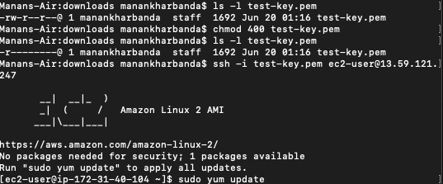

Installing Git

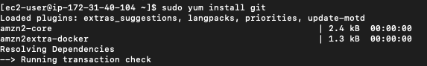

Basic Linux commands

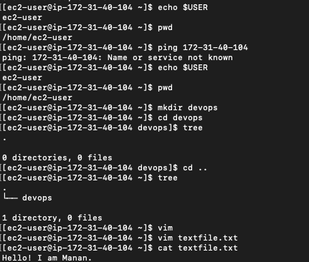

Using move, grep and find commands on a text file

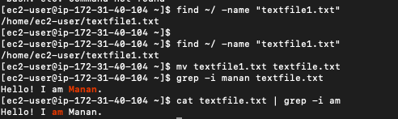

Creating .sh script with user input

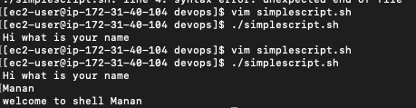

**Git Practice**

Git add, branch, status

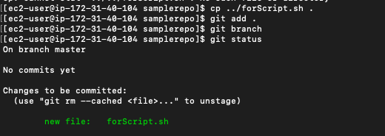

Git commit

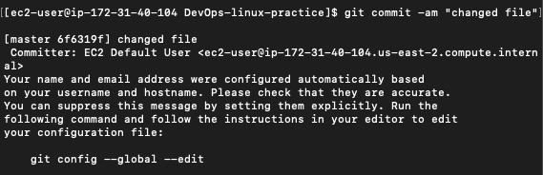

Git push

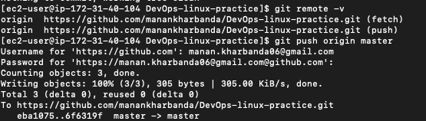

Git checkout and creating new branch

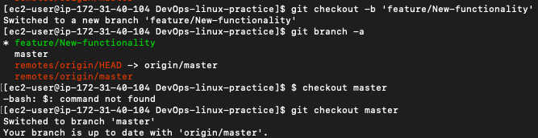



Adding JAVA_HOME variable

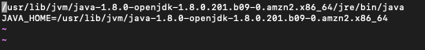



**Jenkins**



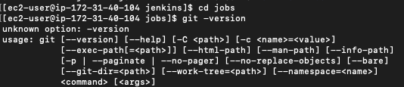

**Maven**



